RESOLUTION NO.__________

RE: CERTIFICATE OF APPROPRIATENESS UNDER THE
PROVISIONS OF THE ACT OF THE PENNSYLVANIA
LEGISLATURE 1961, JUNE 13, P.L. 282 (53
SECTION 8004) AND BETHLEHEM ORDINANCE NO.
3952 AS AMENDED.

WHEREAS, it is proposed to secure a Certificate of Appropriateness for the alteration of the previously approved metal sign at 15 E. Third St.

NOW, THEREFORE, BE IT RESOLVED by the Council of the City of Bethlehem that a Certificate of Appropriateness is hereby granted for the work.

Sponsored by: (s)

(s)

ADOPTED BY COUNCIL THIS DAY OF

(s)
President of Council

ATTEST:

(s)
City Clerk

HISTORIC CONSERVATION COMMISSION

CASE # 523 – It is proposed to secure a Certificate of Appropriateness for the alteration of the previously approved metal sign at 15 E. Third St.
OWNER/APPLICANT: Jessica Kroope / Vito J. Villani

The Commission upon motion by Mr. Cornish seconded by Mr. Loush adopted the proposal that City Council issue a Certificate of Appropriateness for the proposed work described herein:

- The proposal to secure a Certificate of Appropriateness for the alteration of the previously approved metal sign at 15 E. Third St. was presented by Jessica Kroope and Vito J. Villani.

- The sign has been altered from the approved sign, but matches the design approved for the vinyl window sign.

- The new sign has a black background with white lettering and two barber shop graphics.

- The new sign is historically appropriate as modified.

- The proposed motion was unanimously approved.

CU: cu
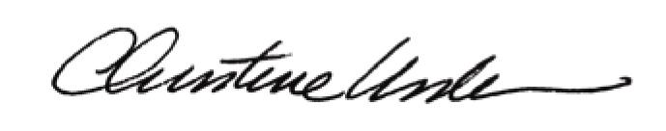

By:

Date of Meeting: November 17, 2014 Title: Historic Officer

